Compressible Flow through Rocket Nozzles

Last Updated: 9/11/2022

## Compressible Flow Principles

The flow of working fluid exhaust gasses through a rocket nozzle falls distinctly into the compressible regime - that is, flows at mach numbers of $M>0.3$. While flows below this velocity can be assumed to have roughly constant density regardless of changes in flow cross sectional area or pressure drops, in a rocket nozzle the flow accelerates *well* past $M=0.3$, meaning that density cannot be assumed to be constant. This means that simplifications such as Bernoulli’s principle cannot be used to predict flow through the nozzle. Instead, a set of property ratios remain constant throughout the flow, known as the isentropic relations, shown below.

$\frac{p_{0}}{{ρ_{0}}^{γ}}=\frac{p_{a}}{{ρ_{a}}^{γ}}$ (1)

$\frac{p_{a}}{p_{0}}=(\frac{ρ_{a}}{ρ_{0}})^{γ}=(\frac{T_{a}}{T_{0}})^{\frac{γ}{γ+1}}$ (2)

Where:

* $p_{0}$ is the stagnation pressure
* $p_{a}$ is the static pressure at some arbitrary point *a* in the flow
* $ρ_{0}$ is the stagnation density
* $ρ_{a}$ is the static pressure at the some point *a*
* $T_{0}$ is the stagnation temperature
* $T_{a}$ is the static temperature at some point *a*
* $γ$ is the specific heat ratio of the fluid[1]

Equations 1 and 2 are fundamental laws governing compressible flows, with the ratios specified in equation 2 being derived from the law specified in equation 1 and conservation of energy. Derivations such as these, and those that follow, will be spared in this document, as they can be quite intensive. Instead, surface-level detailing of relevant equations regarding flow through a nozzle will be outlined in this document.

While design of a very rudimentary engine could be done using only stagnation conditions - or the conditions the fluid is at when it is at a standstill very far upstream, or when it is brought to a stop - several important factors would not be accounted for, namely performance parameters and cooling. To that end, this document will provide the basic equations which can be used to predict the flow conditions throughout the nozzle.

## 

## Mach Number

The Mach number is something many are already familiar with - it is simply how many times the speed of sound an object is traveling. To define it more rigorously, the mach number is defined as the ratio of the flow velocity to the speed of sound in the fluid $a$, outlined in equations 3 and 4.

$a = \sqrt{γRT}$ (3)

$M = \frac{v}{a}=\frac{v}{\sqrt{γRT}}$ (4)

Where:

* $M$ is the dimensionless mach number
* $a$ is the speed of sound in m/s
* $v$ is the flow velocity in m/s
* $T$ is the static fluid temperature in K
* $γ$ is the fluid specific heat ratio
* $R$ is the specific gas constant of the gas in J/kg-K

The mach number is a dimensionless parameter which dictates many compressible flow equations. For our purposes, it is then important to determine the mach number at any given point in the converging-diverging rocket nozzle. Assuming that flow through the nozzle is choked (see document [A]), the mach number at the throat, or minimum area, will always be $M=1$. Upstream, in the converging section, the mach number will slowly rise as the nozzle tightens towards the throat. Downstream of the throat, the flow will accelerate to higher, supersonic mach numbers as it expands down the nozzle. The first step to determining mach number at a given point, assuming choked flow, is to know the area ratio at some point within the nozzle. The area ratio is simply defined as the ratio of the cross-sectional area at some point in the nozzle to the throat area, often denoted $\frac{A}{A^{*}}$, where $A^{*}$ is the throat area.

The equations relating area ratio to mach number can be obtained from Huzel and Huang[1], section 1, with equation 5 relating the area ratio to the mach number at any point throughout the nozzle. Below in figure 1 is an example plot to demonstrate the area ratio shown by this equation.

$\frac{A_{down}}{A^{*}}=\frac{1}{M}(\frac{1+\frac{γ-1}{2}M^{2}}{\frac{γ-1}{2}})^{\frac{γ+1}{2(γ-1)}}$ (5)

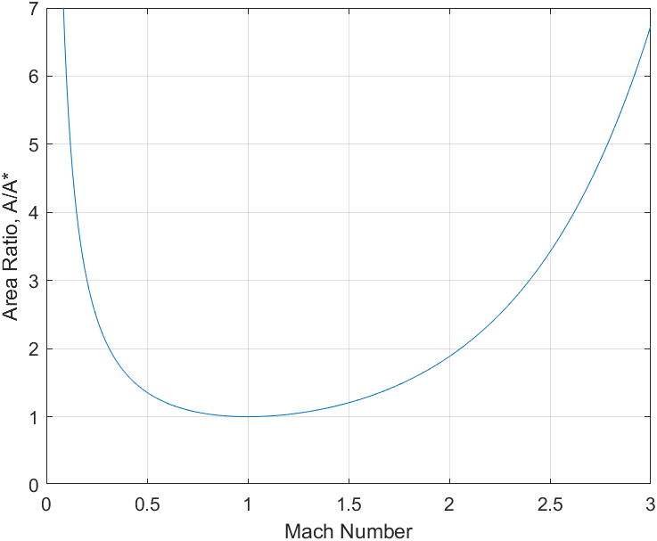

**Figure 1: Plot of Nozzle Area Ratio vs Mach Number**

Note that mach number increases along the x-axis in the figure. This corresponds (qualitatively) to the increase in axial distance through the nozzle, as the flow increases in mach number as it flows through the nozzle. For the sake of demonstration, consider attempting to solve for the mach number at a location in the nozzle with the area ratio $\frac{A}{A^{*}}=2$. There is no closed-form solution for this, but a closed form solution isn’t necessary either. Subtracting 2 from the function for area ratio and plotting will allow for the use of a zero-finding method to solve for the mach number at an area ratio of 2. Such a plot is demonstrated below in figure 2.

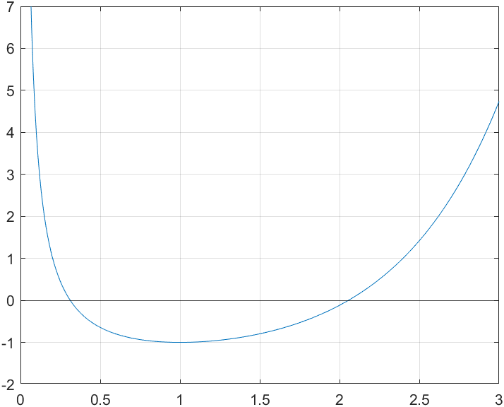

**Figure 2: Plot of Nozzle Area Ratio minus 2 vs Mach Number**

Note that there are two zeros to this plot - one at $M=2.1$ and one at $M=0.3$. The reason for this is that there can be two possible solutions to the mach number at some area ratio: one in the converging section of the nozzle (subsonic) and one in the diverging section of the nozzle (supersonic). It is therefore important to know whether the point is in the converging or diverging section of the nozzle before trying to solve for mach number. This is easy enough as one needs only to compare the axial distance $x$ to the axial downstream distance of the throat $x^{*}$; if $x$ is greater than $x^{*}$, then it must be the supersonic solution ($M>1$), and if it is less than $x^{*}$, then it must be the subsonic solution ($M<1$).

In order to exclude an undesired solution, a bounded zero-finding method could be used. The bounds could then be set to $M=0$ and $1$ for the subsonic portion and $M=1$ and some upper bound so high it is unlikely to be exceeded by the solution, i.e. $M = 30$. Alternatively, a numerical method which finds both zeros and excludes the undesired solution could also be employed. The critical part of any method using this equation is that it must exclude the undesired solution in favor of the one applicable to the point being solved for.

## Calculating Flow Conditions from Mach Number

Once the mach number at a given point is obtained, the static properties at some given point (temperature, pressure, density, etc.) can then be calculated fairly easily from the stagnation properties (i.e. properties when the gas is at/brough to a halt). The stagnation conditions can be assumed to be approximately equal to the chamber conditions[A]. The relations can be drawn from Sutton’s Rocket Propulsion Elements[2], section 3.2. The equations are collected below in equations 6 (Sutton 3-12), 7 (Sutton 3-13), and 8 (derived from equations 7 and 2).

$T=T_{0}(1+\frac{1}{2}(γ-1)M^{2})^{-1}$ (6)

$p=p_{0}(1+\frac{1}{2}(γ-1)M^{2})^{-\frac{γ}{γ-1}}$ (7)

$ρ=ρ_{0}(1+\frac{1}{2}(γ-1)M^{2})^{-\frac{1}{γ-1}}$ (8)

Where:

* $T_{0}$ is stagnation temperature in K
* $T$ is static temperature in K
* $p_{0}$ is stagnation pressure in Pa
* $p$ is static pressure in Pa
* $ρ_{0}$ is stagnation density in kg/m^3
* $ρ$ is static density in kg/m^3

Combined with the methods for finding Mach number numerically, these equations can be used in combination with the chamber conditions to calculate the static conditions such as pressure or temperature at any given point throughout some nozzle being designed for or modeled.

## References and Sources

[1] [Huzel & Huang](https://drive.google.com/drive/u/1/folders/1rtMTDnJylXlQQApa5ANx0DKBsVjKrJ2a)

[2] [Sutton](https://drive.google.com/file/d/1muyScRo6bWxT6AzNZnpIaxudrqsAPFAy/view?usp=sharing)

## Related Documentation

[A] [Chamber Flow Modeling](https://docs.google.com/document/d/1jLYpAgBIF4DAZvxFLMegq2dOw-f8xS7uXNU71RqToM4/edit#)

1. See document [A], section *Specific Heats and Ratio of Specific Heats* for more detail